


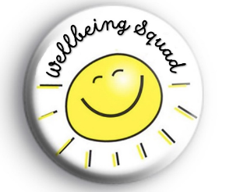

“Nothing about us, without us!”
Wellbeing squad 2026-2027 Application Form
What are we looking for?
We are very excited to be looking for new members of the BPS Wellbeing Squad! The pupils have been briefed about what the role entails and are filling out this application form because they wish to be part of the team! They are keen to help to create positive playtimes, help with friendship issues, support the new OPAL play scheme and in the case of the older children, become a peer mentor for children in school. They will also be helping promote positive mental health and wellbeing by leading and taking part in assemblies and other events that we organise throughout the year.
Below are some questions to be completed in order to apply to be part of the team. Please think carefully when answering so that responses demonstrate suitability.
Name:__________________________ Class:_________________________
What does it take?
Motivation
What motivates you to be part of this team and what qualities do you have that will help you be successful?

Time – the job will involve giving up some playtimes and coming to the wellbeing after school club on a Tuesday.
What are your thoughts about giving up 1 or 2 breaktimes a week to fulfil the role on the Wellbeing Squad?

Communication Skills
Tell us a about a time that you have shown great listening/speaking skills.

Problem Solving skills
Explain what you would do to help in this situation.
“While you are out on the playground as a member of the “Wellbeing Squad”, a child that you don’t know has come to you for help with a friendship issue. They explain that their friends keep ignoring them and running away and they don’t know what to do.”

Hobbies and Interests
If you were to become a “buddy” to another child it is great if you share or enjoy similar hobbies or interests. Tell us things that you are interested in or like to do as a hobby.

Please hand this form in to your class teacher by Friday 24th September so that you can be considered for a role in the BPS “Wellbeing Squad”. We will then look through the applications and get back to you by the end of the week.
Thank you so much for being motivated and taking the time to fill in this application form!
Kind Regards
Mrs Hares

